Fuzzy Logic Application About Bank-Customer Relation in Participation Banking

Ömer Faruk Aslan, Yusuf Eren Karagöz, Ekrem Güler, Tayfur Durlanık, Şükrü Yasin Yıldırım, Affan Buğra Özaytaş, Burak Han Demirbaş

A B S T R A C T

Participation banking needs some risk assessments required such as profit and loss sharing(PLS).[1][3] In conventional banking the interest is fixed but this paradigm shift (participation banking) places significant emphasis on qualitative attributes of the entrepreneur and the potential of the business venture.[3] With this study we highly recommend to use fuzzy logic to evaluate the bank-costumer relationships.[2][26] In this study Mamdani-type fuzzy model used to describe three important input variables: Trust Score, Project Viability, and Equity Ratio.[4] With some expert banking knowledge it processes inputs to generate unified partnership score. After getting a data which has more than 700 applicants and after some results of simulations it shows that the proposed model effectively classifies applications into reject, monitor, and approve categories.[26] The findings supports that a fuzzy logic provides strong, transparent, and ethically aligned decision support system.

Keywords: Participation Banking, Fuzzy Inference System (FIS), Profit and Loss Sharing (PLS), Risk Mitigation, Mamdani Model.

1.Introduction
The global financial landscape has undergone a paradigm shift with the rapid spread of participatory banking, also known as Islamic banking.[3] Unlike traditional banking, which primarily operates on debt-based instruments and interest,[1][15] participatory banking is based on asset-backed financing and risk-sharing principles. At the heart of this system are the concepts of Mudharabah (profit sharing) and Musharakah (joint venture)[3][5], where the bank acts not only as a lender but also as a partner in the entrepreneurs business ventures. This profit and loss sharing (PLS) model is reveals with ethical and equitable financial distribution but[20][21] exposes it to a higher degree of uninterpretable information and agent-client risks than traditional collateral-based lending.[6][18]

Decision-making for a traditional credit scoring model is usually based on binary and largely quantitative financial history. However, participatory banking requires a more holistic assessment of the potential partner. The decision to enter into a partnership is influenced by variables that are often vague, subjective, or difficult to precisely measure, such as the entrepreneur's credibility (Trust Score), the potential success of the business idea (Project Viability), and the partner's own capital contribution (Equity Ratio). Traditional "crisp" mathematical logic, which classifies data into definite "0 or 1" sets,[2] often fails to capture the nuances of these human and business factors. For example, a project may not be definitively "good" or "bad," but rather "moderately promising"; this is a situation where binary logic struggles to function effectively.

To solve this problem, Fuzzy Logic, published by Lotfi Zadeh (1965),[2] offers a better computation. Fuzzy Logic allows for approximate values and degrees of accuracy instead of a set of limits, and mimics the human mind.[9] The study uses terms like "Risky," "Normal," or "Reliable" to model uncertainty, making it a better tool for qualitative assessment required in participatory banking.

This study proposes a Fuzzy Inference System (FIS) designed to optimize the bank-client relationship in participatory finance. Using a Mamdani-type fuzzy model, we integrate three critical input variables: Applicant Trust Score, Project Viability, and Equity Ratio. Our initial goal is to create a comprehensive Partnership Score that guides the bank's decision-making process toward three actions: Reject, Monitor, or Approve. This approach aims to bridge the gap between subjective expert judgment and objective automated scoring, ultimately improving the sustainability and efficiency of Mudharabah and Musharakah contracts.

2. Designed System
This study is using the Mamdani type fuzzy inference system for the scoring that the bank will give to the customer in participation banking evaluations.[4][10] This system is designed to produce a single and applicable decision criterion by processing heterogeneous data types ranging from financial ratios to subjective expert evaluations.[10] The proposed model consists of three input parameters and one output parameter.
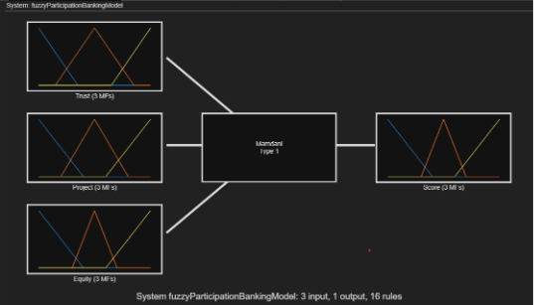
Figure 1. Architecture of the Mamdani Fuzzy Inference System
2.1. Input Parameters
The selection of input variables is based on the "5 Cs of Credit" framework.[22], specifically adapted to the risk-sharing nature of participation banking.
- Trust Score: Unlike traditional banking islamic banking examines the character of the partner. The trust score is a variable quantified on a scale of 0 to 20. It represents the banks qualitative evaluation of the applicants reputation,credit history and moral integrity. [18][26]
- Project Viability: This parameter assigning a value between 0 and 10 to measure the economic viability and potential profitability of the proposed business venture. A low score shows that a venture with unclear objectives, while a high score shows situations with strong profit potential necessary for the Mudharabah partnership to generate returns. [8][26]
- Equity Ratio: Calculating the ratio of the capital contributed by the entrepreneur to the total investment. It is shown as 0.0 and 1.0 in the dataset. A higher equity ratio aligns the entrepreneur s interests with the banks interests. [6][18]
2.2. Output Parameter
- Partnership Score: The output of the blurring process is a value ranging from 0 to 100. This score serves as a comprehensive decision support metric. Unlike traditional binary results, this score is allowing for a detailed classification of applications. Based on simulation results from the proposed model, the score determines the final banking decision by dividing applications into three strategic zones: Reject, monitor and approve.

3. Modelling: The Fuzzy Inference System
The proposed decision support system is the Mamdani-type Fuzzy Inference System (FIS) modeled with the MATLAB Fuzzy Logic Designer. This architecture was chosen because of its intuitive ability to capture the expert knowledge and human-like reasoning processes required when evaluating the qualitative aspects of a partnership (Mudharabah) practice. The modeling process consists of three distinct stages: Fuzzification (Definition of Membership Functions), Knowledge Base construction (Rule evaluation), and Defuzzification.”

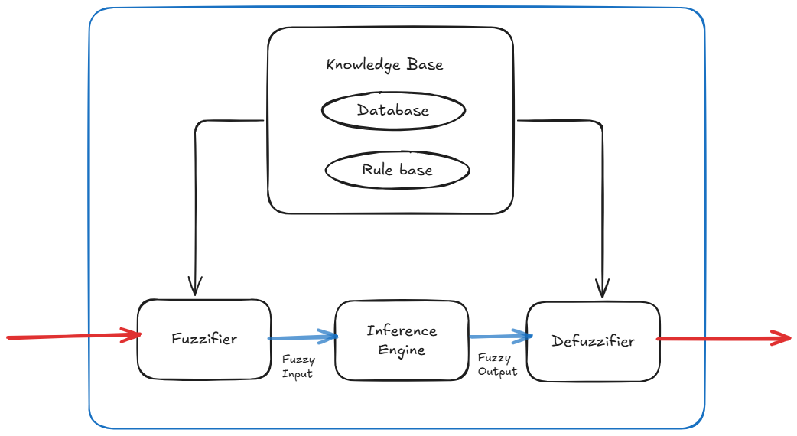 Figure 2. Conceptual diagram of the Fuzzy Inference System showing the Fuzzifier, Inference Engine, and Defuzzifier. [27]

3.1. Membership Functions (MFs)
In the fuzzification, our main goal is to turn crisp numbers into fuzzy linguistic variables. We decided to use Triangular Membership Functions (trimf) for every single input and output variable.
Why did we choose this specific shape? Simple: Triangular functions are computationally very efficient. Plus, they handle data transitions with clean, linear lines, which makes the model easier to interpret compared to complex curves.[10][24] Basically, the system assigns a "degree of membership," µ(x), which slides anywhere between 0 and 1 for each variable.
Below, we define exactly how this triangular function works mathematically:
Mathematical Definition of Triangular Membership Function: In this formula, let x be the input value. The parameters (a, b, c) represent the fuzzy set's lower bound, its peak, and its upper bound, respectively. The membership degree µ(x) is calculated as follows:
$$μ_{trimf}\left(x;a, b, c\right)=\left\{\begin{aligned}0, &x<a \\ \frac{x-a}{b-a}, a<x≤b \\ \frac{c-x}{c-b}, b<x<c \\ 0, &x≥c\end{aligned}\right.$$

Table 1. Mathematical Parameters for Membership Functions
Variable | Linguistic Set | Parameters (a, b, c) | Function Type
Trust Score | Risky | [-5, 0, 7] | Trimf
 | Normal | [3, 10, 17] | Trimf
 | Reliable | [13, 20, 25] | Trimf
Project Viability | Weak | [-2, 0, 4] | Trimf
 | Moderate | [2, 5, 8] | Trimf
 | Promising | [6, 10, 12] | Trimf
Equity Ratio | Low | [-0.2, 0, 0.4] | Trimf
 | Fair | [0.3, 0.5, 0.7] | Trimf
 | High | [0.6, 1, 1.2] | Trimf
Note: Parameters extending beyond the defined domain (e.g., -5 or 1.2) are intentionally configured to create 'shoulder-shaped' sets. This ensures that boundary values (such as 0 or 1) achieve a membership degree of µ(x)=1.0.

The specific configurations for the input parameters are as follows:
- Trust Score (Input 1): Defined over a range of [0, 20]. It is segmented into three overlapping linguistic sets: risky, normal and reliable
- risky covers the lower bound, representing applicants with poor credit history.
- reliable covers the upper bound, representing high-integrity partners.
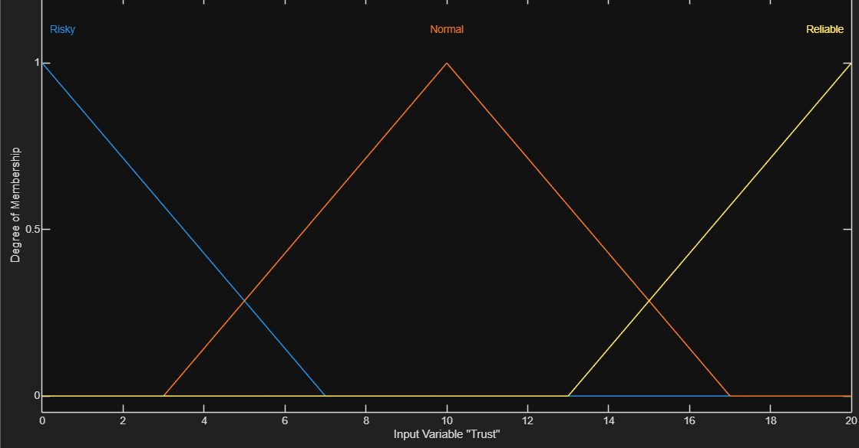
Figure 3. Membership Functions for Trust Score.

- Project Viability (Input 2): Defined over a range of [0,10]. The sets are weak,moderate and promising.The function captures the economic feasibility of proposed venture.
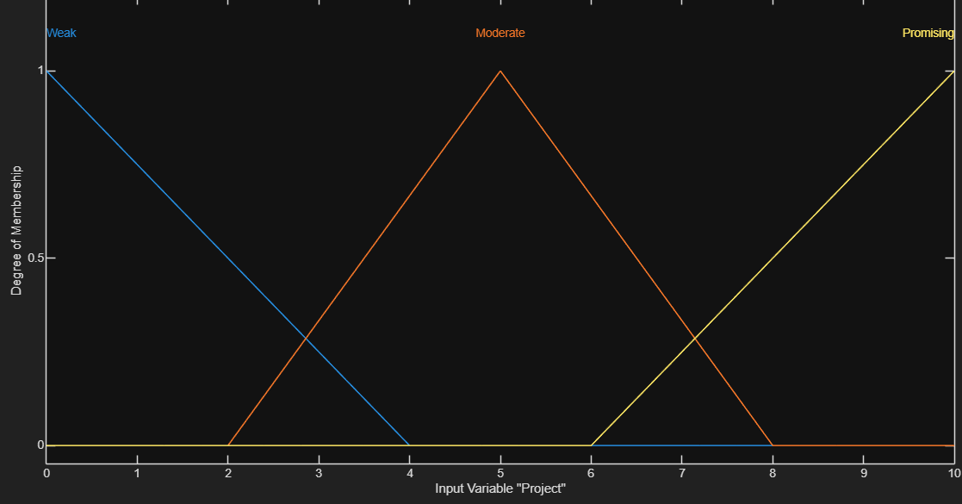
Figure 4. Membership Functions for Project Viability.
- Equity Ratio (Input 3): This function defined over the normalized range of [0, 1]. Sets are low, fair, and high. input models the capital contribution where a high membership shows a significant personal investment by the entrepreneur, reducing risk.
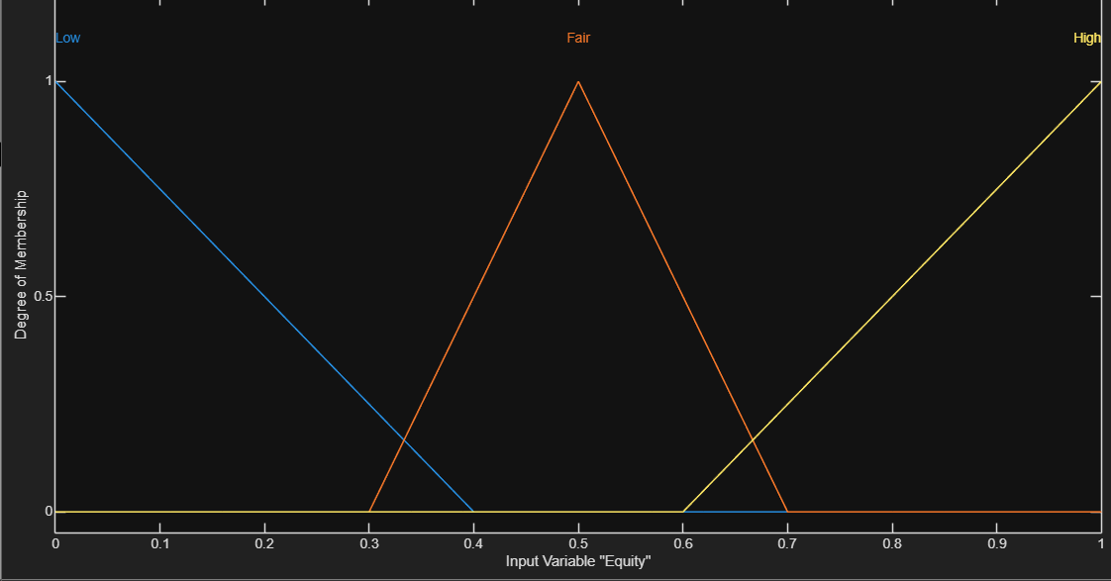
Figure 5. Membership Functions for Equity Ratio.
- Partnership Score (Output): This function defined over the range of [0, 100] and classified into reject, monitor, and approve.
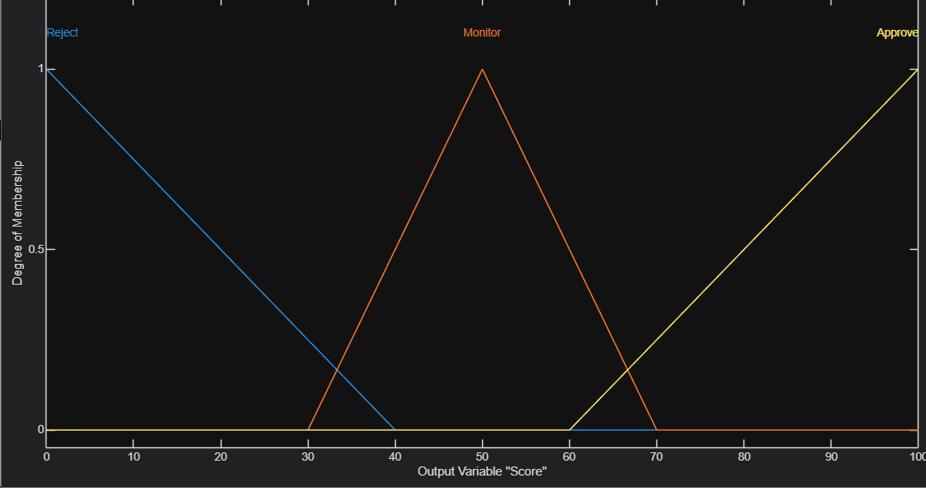
Figure 6. Membership Functions for the Output Partnership Score.
3.2. Rule Base and Logic
The system has an intelligence which derived from a rule base consisting of 16 conditional statements.[4][23] These rules are mapping the complex nonlinear relationships between inputs and the output. The implication mechanism uses the min-max method. the AND operator is applied using the Minimum function and the OR operator uses the maximum function.[10][25]
Category 1: REJECT (High Risk Scenarios)
These rules identify applicants with insufficient trust or project viability relative to their capital contribution, triggering an immediate rejection to protect the bank's assets.
- If (Trust is Risky) and (Project is Weak) then (Score is Reject)
- If (Trust is Risky) and (Project is Moderate) and (Equity is not High) then (Score is Reject)
- If (Trust is Risky) and (Project is Promising) and (Equity is Low) then (Score is Reject)
- If (Trust is Normal) and (Project is Weak) and (Equity is not High) then (Score is Reject)
- If (Trust is Reliable) and (Project is Weak) and (Equity is Low) then (Score is Reject)

Category 2: MONITOR (Conditional Evaluation)
These rules represent the "gray area" where the applicant shows potential but lacks strength in one dimension. The system assigns a moderate score, suggesting manual review or additional collateral.
- If (Trust is Risky) and (Project is Moderate) and (Equity is High) then (Score is Monitor)
- If (Trust is Risky) and (Project is Promising) and (Equity is not Low) then (Score is Monitor)
- If (Trust is Normal) and (Project is Weak) and (Equity is High) then (Score is Monitor)
- If (Trust is Normal) and (Project is Moderate) and (Equity is not High) then (Score is Monitor)
- If (Trust is Normal) and (Project is Promising) and (Equity is Low) then (Score is Monitor)
- If (Trust is Reliable) and (Project is Weak) and (Equity is not Low) then (Score is Monitor)
- If (Trust is Reliable) and (Project is Moderate) and (Equity is Low) then (Score is Monitor)
Category 3: APPROVE (Partnership Suitability)
These rules correspond to ideal or near-ideal partnership conditions where the combination of trust, project quality, and equity minimizes the risk of Mudharabah investment.
- If (Trust is Normal) and (Project is Moderate) and (Equity is High) then (Score is Approve)
- If (Trust is Normal) and (Project is Promising) and (Equity is not Low) then (Score is Approve)
- If (Trust is Reliable) and (Project is Moderate) and (Equity is not Low) then (Score is Approve)
- If (Trust is Reliable) and (Project is Promising) then (Score is Approve)

3.3. Defuzzification and Input-Output Surface Analysis
The final step is defuzzification. Basically, we need to turn our fuzzy results into one concrete number: the Partnership Score (0-100). We deliberately chose the Centroid Method (Center of Gravity) instead of the 'Mean of Max'.
Why did we make this choice? Because the Centroid method ensures the output curve stays smooth. It prevents those sharp, unrealistic jumps between decision zones, giving us a much more stable assessment compared to other techniques. [10][25]
To get the final crisp output $Z^{*}$, we apply the standard Centroid formula:
$$Z_{COA}=\frac{\int{μ_{Score}\left(z\right)×zdz}}{\int{μ_{Score}\left(z\right)}}$$
The relationship between inputs and the output score can be visualized via the Control Surface.

4. Surface Viewer Analysis
To really understand how the inputs drive the final score, we used the MATLAB Surface Viewer. This tool gives us a 3D map of the system’s logic. By looking at these surfaces, we could verify that our model "thinks" like a real banker. For instance, the visual data proves that if "Trust" crashes, the approval score follows it down immediately—regardless of how good the project is.
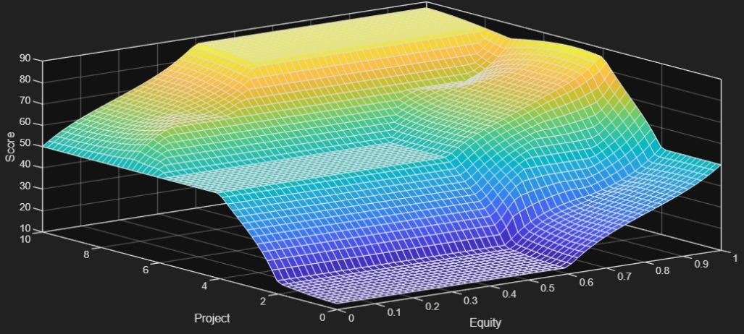
Figure 7. Surface plot showing the interaction between Trust Score and Equity Ratio
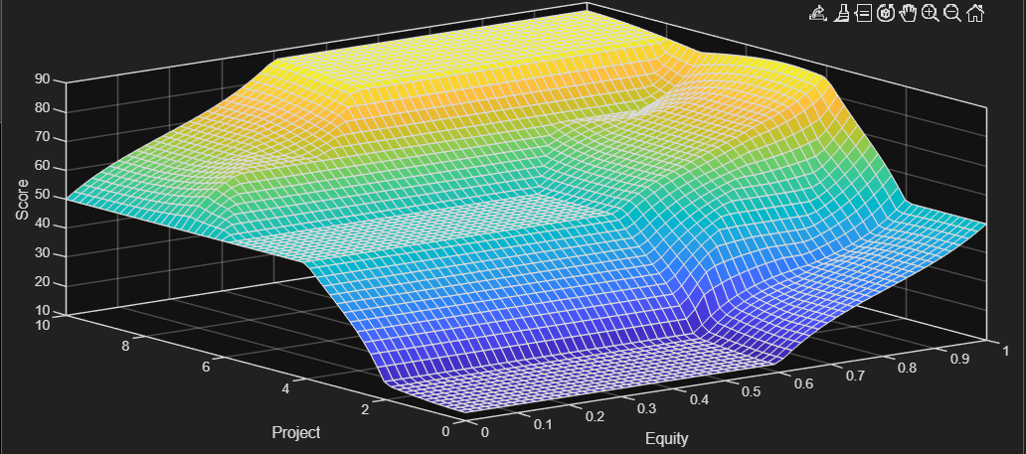
Figure 8. Surface plot showing the interaction between Equity Ratio and Project Viability.
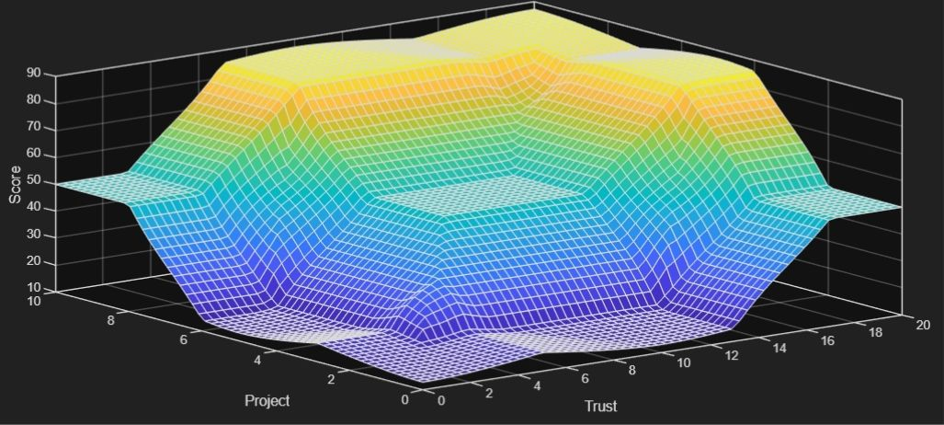
Figure 9. Surface plot showing the interaction between Trust Score and Project Viability.

5. Conclusion
Traditional binary credit scoring often fails in participation banking. To fix this gap, we developed a Fuzzy Inference System (FIS). [14][26] Unlike standard models, our Mamdani-type system focuses on three specific qualitative inputs: Trust Score, Project Viability, and Equity Ratio. This approach captures the subjective nature of Profit-and-Loss Sharing (PLS) contracts much better than rigid mathematical models.
We tested the system on a dataset of over 700 applicant profiles. The simulation results showed that our model mimics expert human reasoning with high accuracy. [8][26] It produces a single "Partnership Score" that sorts applicants into three clear zones: Reject, Monitor, and Approve.
Crucially, our model introduces "Dominant Conditions." This feature allows a high-potential project to secure funding even if the entrepreneur has low capital, which breaks the rigidity of older evaluations. In short, this research proves that Fuzzy Logic offers a transparent, robust, and ethical tool for risk management in Islamic finance. [1][2][3][26]

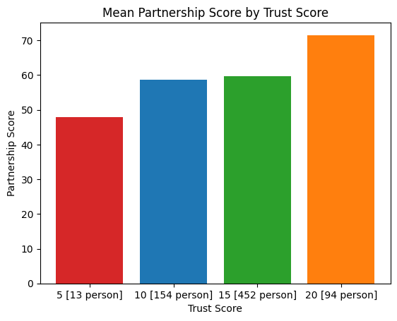
Figure 10. Mean Partnership Score by Trust Score

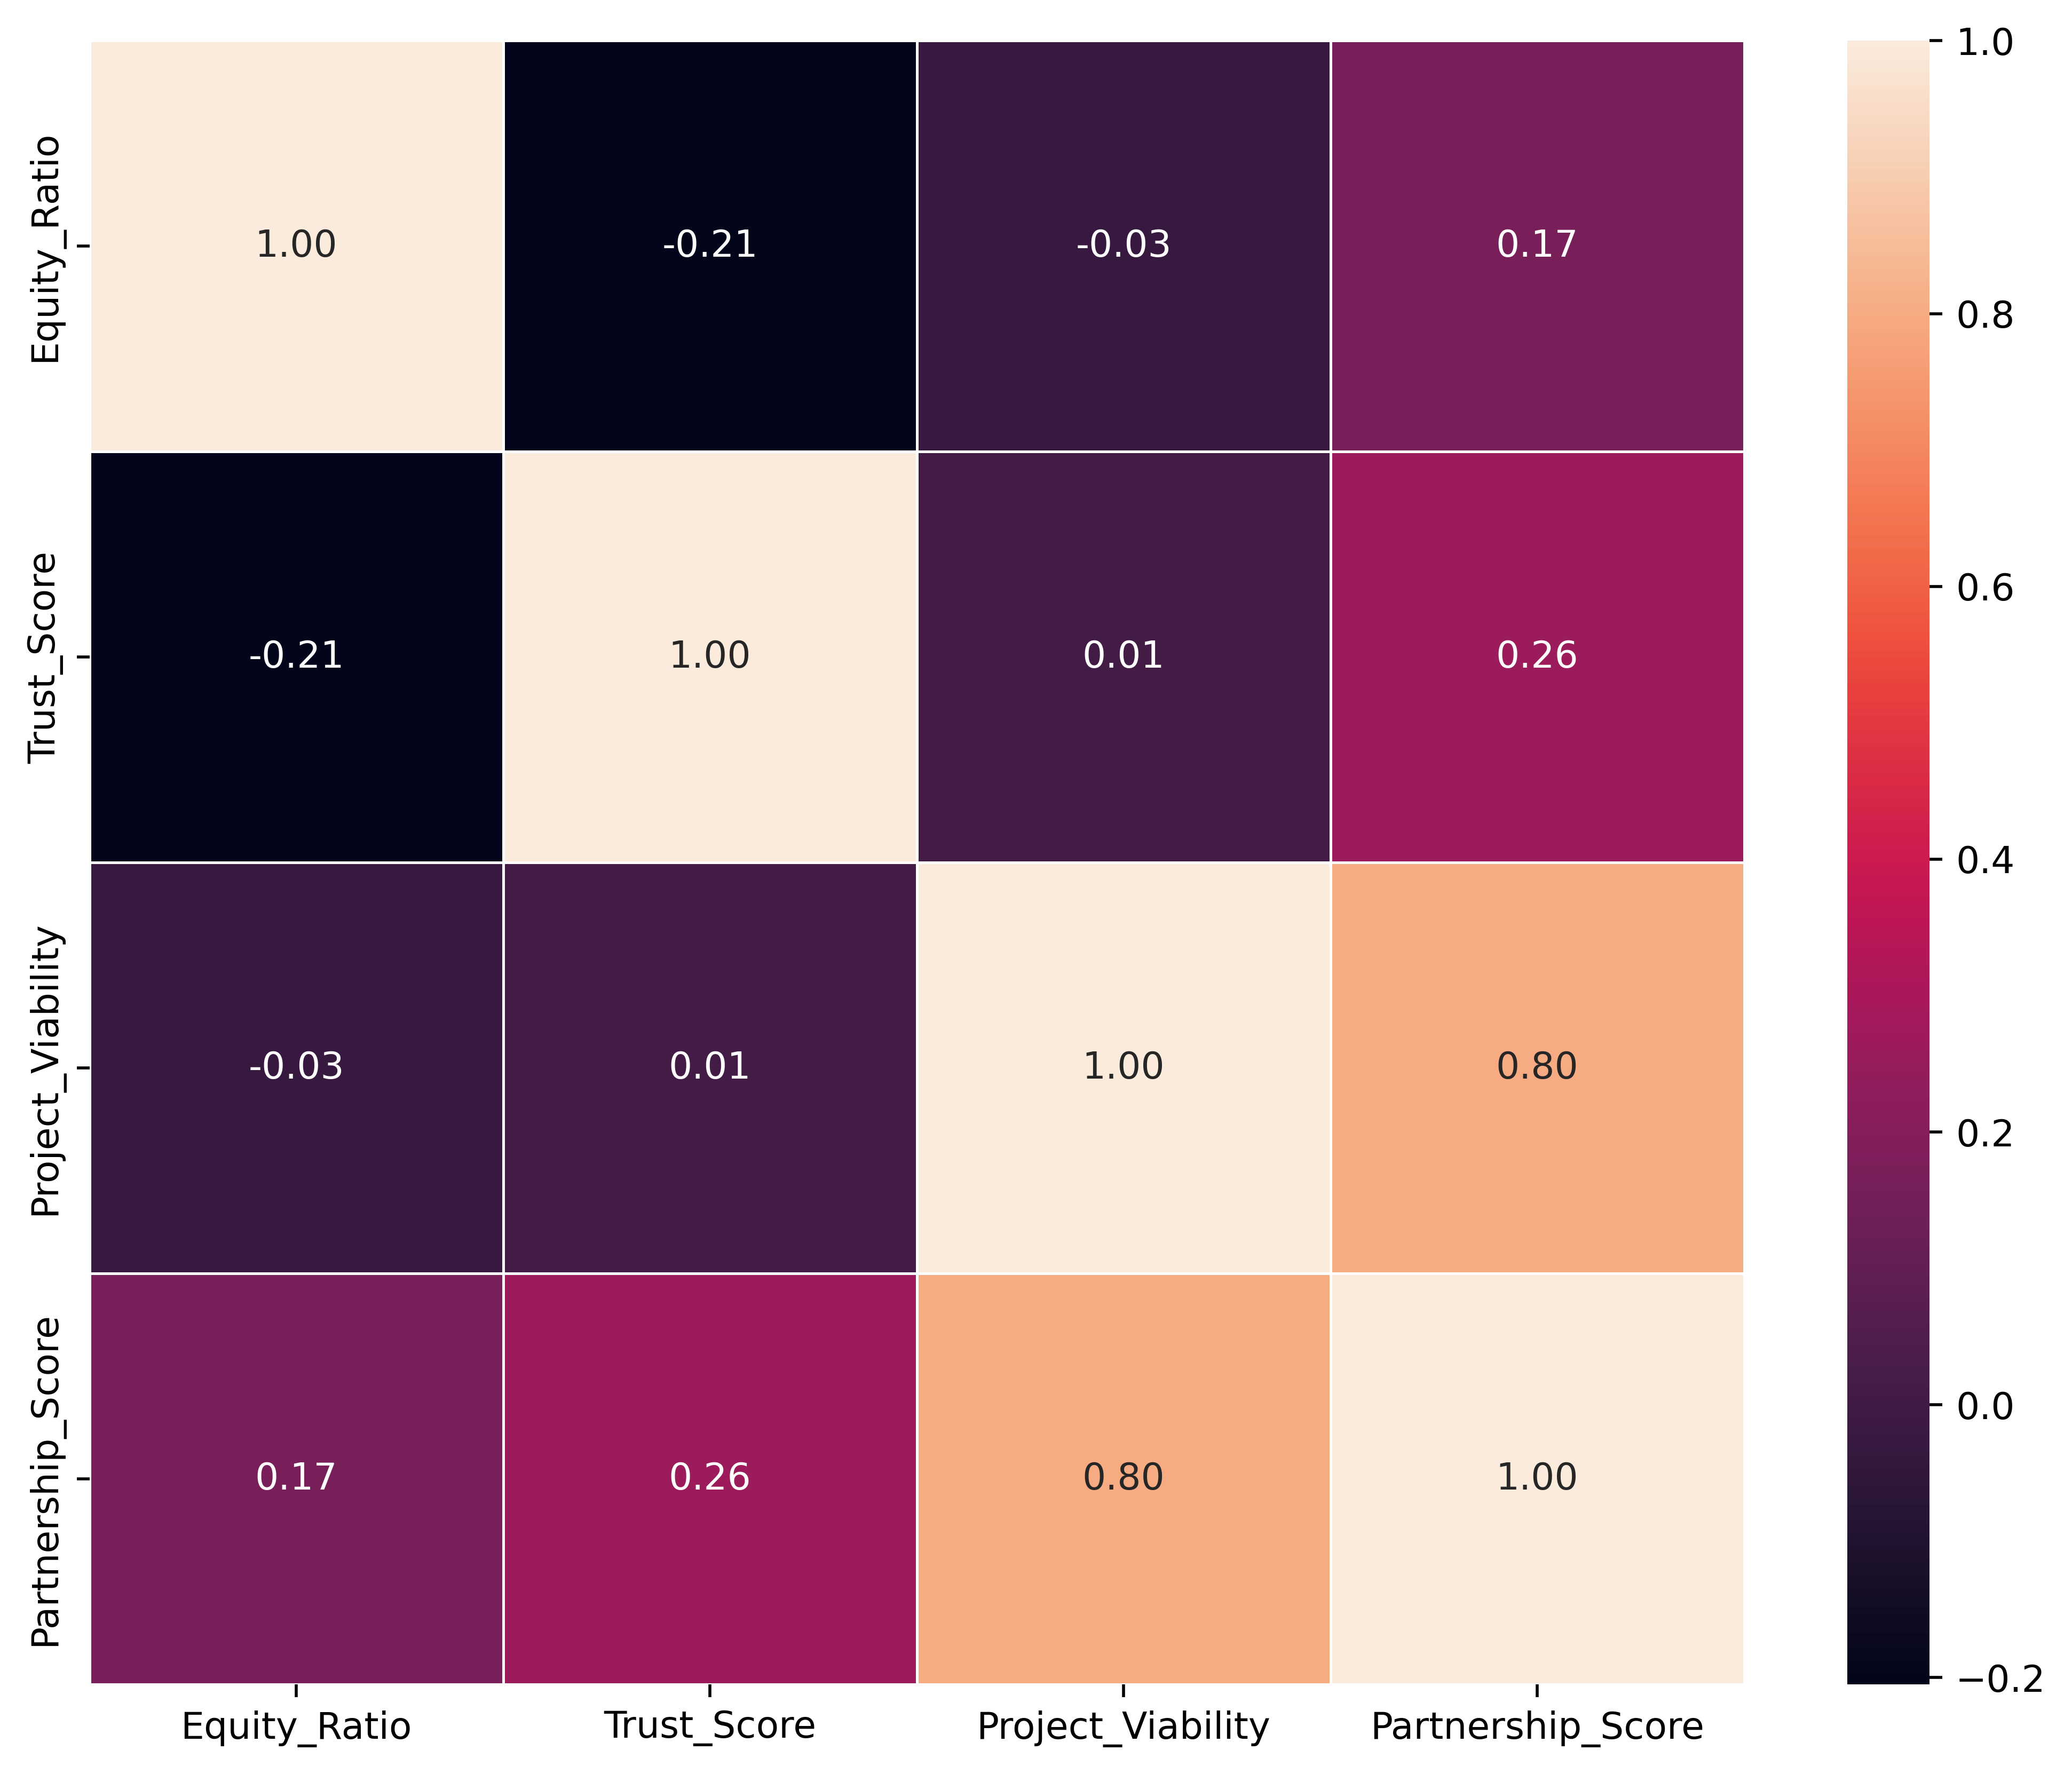
Figure 11. Correlation between parameters and output

References
[1] Chapra, M. U. (2000). The Future of Economics: An Islamic Perspective. The Islamic Foundation.
[2] Zadeh, L. A. (1965). Fuzzy sets. Information and Control, 8(3), 338-353.
[3] Iqbal, Z., & Mirakhor, A. (2011). An Introduction to Islamic Finance: Theory and Practice. John Wiley & Sons.
[4] Mamdani, E. H., & Assilian, S. (1975). An experiment in linguistic synthesis with a fuzzy logic controller.International Journal of Man-Machine Studies.
[5] Ayub, M. (2007). Understanding Islamic Finance. John Wiley & Sons.
[6] Khan, T., & Ahmed, H. (2001). Risk Management: An Analysis of Issues in Islamic Financial Industry. Islamic Development Bank.
[7] Dymova, L., Sevastjanov, P., & Tikhonenko, A. (2010). An approach to generalization of fuzzy TOPSIS method. Information Sciences.
[8] Lahsasna, A., Bhatti, T., & Ahmad, R. (2010). Integration of fuzzy logic and AHP for credit risk assessment in Islamic banking. Journal of Islamic Finance.
[9] Klir, G. J., & Yuan, B. (1995). Fuzzy Sets and Fuzzy Logic: Theory and Applications. Prentice Hall.
[10] Ross, T. J. (2009). Fuzzy Logic with Engineering Applications. John Wiley & Sons.
[11] McNeill, F. M., & Thro, E. (1994). Fuzzy Logic: A Practical Approach. AP Professional.
[12] Zimmermann, H. J. (2011). Fuzzy Set Theory—and Its Applications. Springer.
[13] Kahraman, C., et al. (2004). Multi-attribute comparison of catering service companies using fuzzy AHP. IJPE.
[14] Metawa, N., Hassan, M. K., & Elhoseny, M. (2017). Genetic algorithm based model for optimizing bank lending decisions. Expert Systems with Applications.
[15] Obaidullah, M. (2005). Islamic Financial Services. Scientific Publishing Centre.
[16] El-Gamal, M. A. (2006). Islamic Finance: Law, Economics, and Practice. Cambridge University Press.
[17] Askari, H., Iqbal, Z., & Mirakhor, A. (2009). New Issues in Islamic Finance and Economics. Wiley.
[18] Akkizidis, I. S., & Khandelwal, S. K. (2008). Financial Risk Management for Islamic Banking and Finance. Palgrave Macmillan.
[19] Rosly, S. A. (2005). Critical Issues on Islamic Banking and Financial Markets. Dinamas.
[20] Hasan, Z. (2011). Islamic Banking and Finance: An Integrative Approach. Oxford University Press.
[21] Civan, M., & Simsek, M. (2009). The effect of Islamic banking on economic growth. International Journal of Economics and Finance.
[22] Zopounidis, C., & Doumpos, M. (1999). A multicriteria decision aid methodology for sorting decision problems. Computational Economics.
[23] Cox, E. (1994). The Fuzzy Systems Handbook. AP Professional.
[24] Sivanandam, S. N., Sumathi, S., & Deepa, S. N. (2007). Introduction to Fuzzy Logic using MATLAB. Springer.
[25] Hellendoorn, H., & Thomas, C. (1993). Defuzzification strategies regarding fuzzy logic control. ISUMA.
[26] Yedder, N. (2018). Modeling Credit Risk for Islamic Banks using Fuzzy Logic. Journal of Risk and Financial Management.
[27] Basic structure of a fuzzy inference system.

